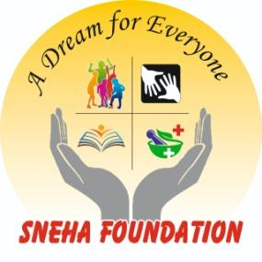
Introduction of the Institution:
One third of the total population of Bhavnagar lives in slums. If one had peeked into life living in this slum, one could see for oneself what the little boys and girls growing up here would be like when they came of teenage. This slum is a school that teaches laziness, beatings, violence, exploitation, illiteracy, unemployment, sexual appetite, extortion, prostitution and many more.
Here the girl becomes a mother at a tender age. They cannot pay attention to upbringing. They often give birth to children. Alcohol is sold freely and easily here. Here Drug sales and gambling issues are found inside the house and outside the house everywhere. To meet these costs, the business of raising money at high interest rates has spread like wildfire. Taking advantage of the compulsion of the poor to work for less money.
My observations are not bookish, but based on my fieldwork in the slums. The government pays the least attention to these slums. Whether the field is education or cleaning work, health or employment. Whether it is for social reform or crime prevention, it is useless for the government to have any hope. Little boys living in big slums wander around all day without any intention as they do not know what to do. Initially weaving garbage, selling plastics, then gradually gambling, watching adult movies, engaging in sexual activities, becoming addicted to drugs, selling drugs, getting drunk, eating tobacco, smoking pick pocketing, stealing from people's homes, He sells goods to the janitors, goes to the temple on Monday and collects Prasad. Everything starts from a very young age.
This slum is the birthplace of crime because the people living here do not have the responsibility to raise their children, do not send them to school, does not follow any social policy rules so crime continues here and most of the people in the slum are involved in some crime. So how do boys get ready and come out in such an environment?
Boy rapists are also here. And girls who have been raped are also here. But very few of them come out. A few of the city's middle-class incidents come out today. But the media does not pay attention to such children as they are poor, destitute and uncountable.

This revelation is an impression - which is actually true that a girl who has been raped will bear it herself. But she doesn’t complain to the Police, because? A girl who has been the victim of many such reasons due to embarrassment, fear of social stigma, court push and examination, harassment of witnesses, long delay in judgment, many cases being delayed in the court and new dates being given. A girl who is a victim of many such reasons is mentally and physically broken and hesitant to complain.
What do the educated or uneducated youth of slums, villages or cities have in this society now? Everything except the values ​​of living - beer - pubs, the pleasure of fast driving, minimally dressed men and women appearing in the public news, loud music and booby-trapped body performances. With all these problems in mind, the founder of the organization, Mr. Gurpreet Singh Gill, started the "Sneha Foundation" on September 6, 2009.
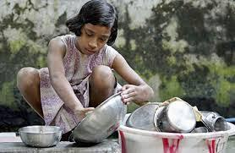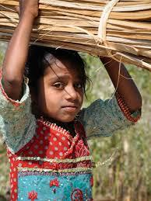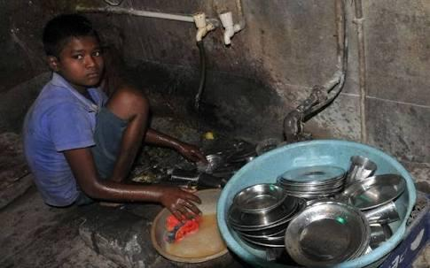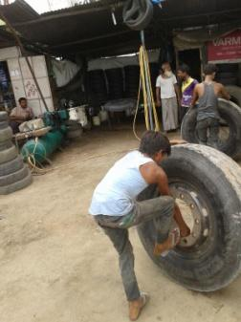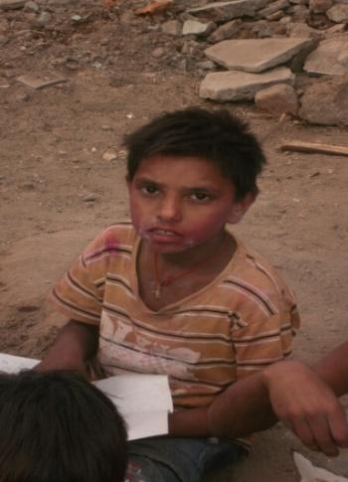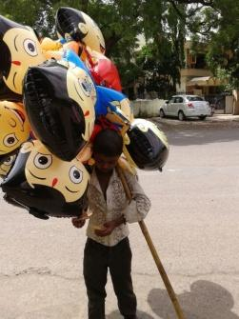

Based on our survey experience after the last 13 years of our work experience, the situation is that today the society is moving forward a lot. People came from 2G networks to 3G and 4G growing up but there is a class in the society even today where there is still a lack of love, warmth, emotion or culture. The main reason why children cannot be brought up properly is that both the parents have to go to work since morning to evening. Children have to live a lonely life without parents all day because they have to go to work till evening. As a result, children cannot be brought up properly, those who lack of moral culture are not motivated to get education. That is why children are driven by bad habits and the result is this. This slum is the birthplace of crime because the people living here do not have the responsibility to raise their children, not to send them to school, not to follow any social policy norms so crime is rampant here and most of the people in the slum are involved in some crime. So how do boys get ready and come out in such an environment?
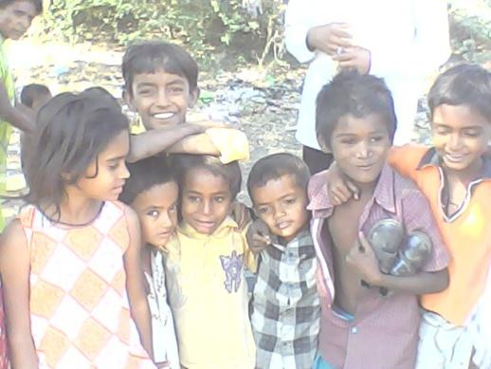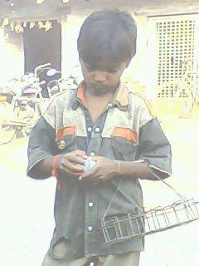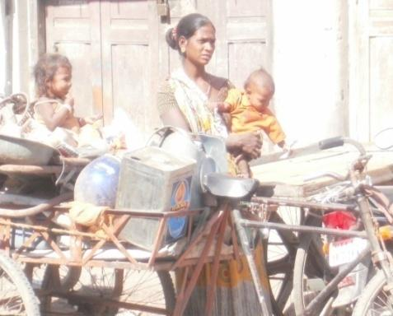
If many parents take their children with them, the children will suffer serious injuries and the child will suffer. Death occurs. Many parents take their children there to help with the labor and then the child is motivated towards child labor. Considering each of these problems and based on our study the organization is working for these children. In which these poor and compelled parents deprived their children of primary education , get the fragrance of the sacraments, get the values ​​of living, get good food, get the benefit of sports, peace of mind and try to move forward in life. We are trying to give them values so that they can progress in their lives.

Activities of the Institute
Educational Activities
Activity Leaning Center -
In the "Activity Learning Center", children are taught every evening from 4:30 to 7:30 through our uniquely modified method. In this center activities are done to increase the reading, writing and arithmetic ability of children from 3 to 17 years. In this center the child learns by playing and independently. Along with this, Bal Mandir has been arranged for children from 3 to 6 years. In addition, a library is set up to enhance the child's reading ability. And efforts are made to ensure that children who are left behind in their studies get a proper education. At the same time giving proper education to children who involved in labor activity. Activities that increase children's knowledge are carried out through cultural programs, tours and other activities. At present more than 450 children are getting education in the institute. Location of Activity Learning Center: - Road from Prabhudas Lake to Ruvapari, khancho in front of Bahuchar Mataji Temple, Opposite Hanumanji's Otala, Khedutwas, Bhavnagar.
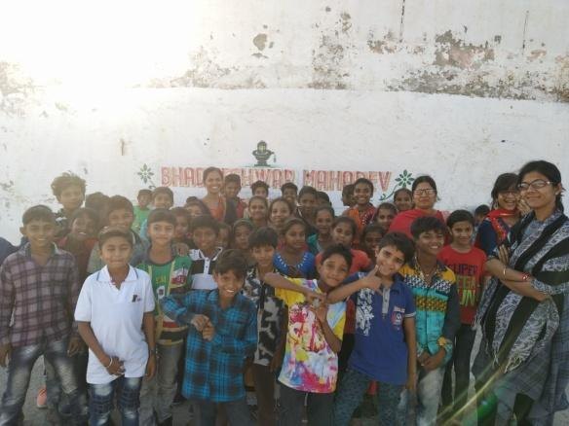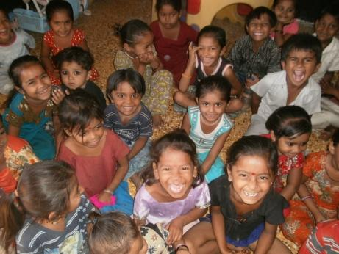
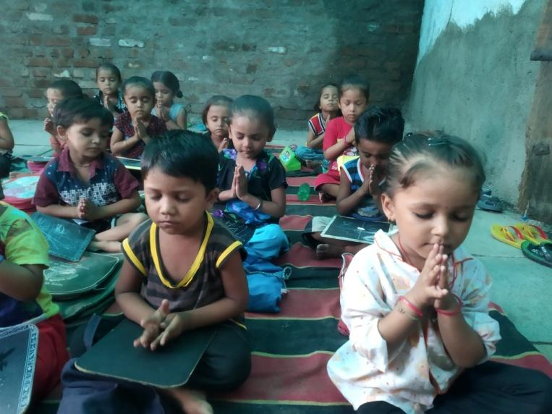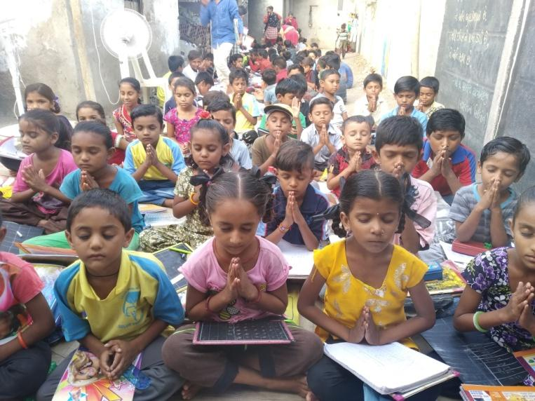

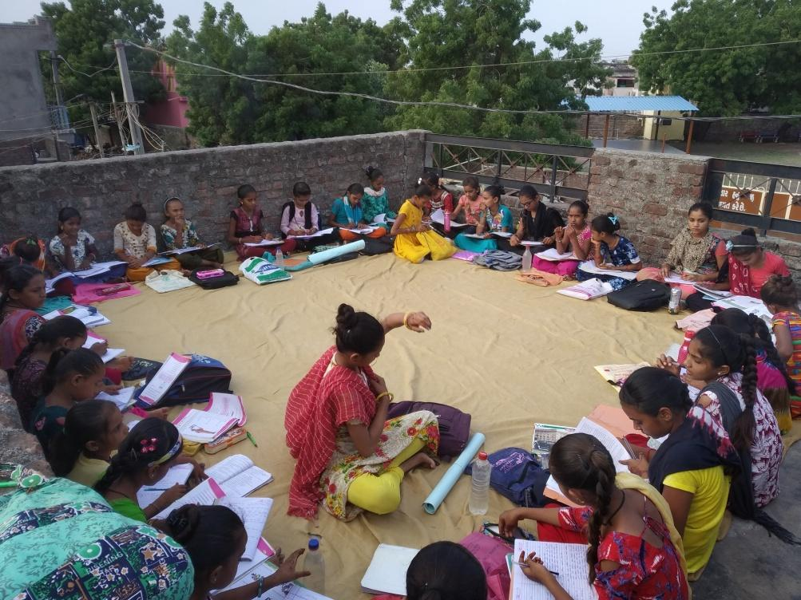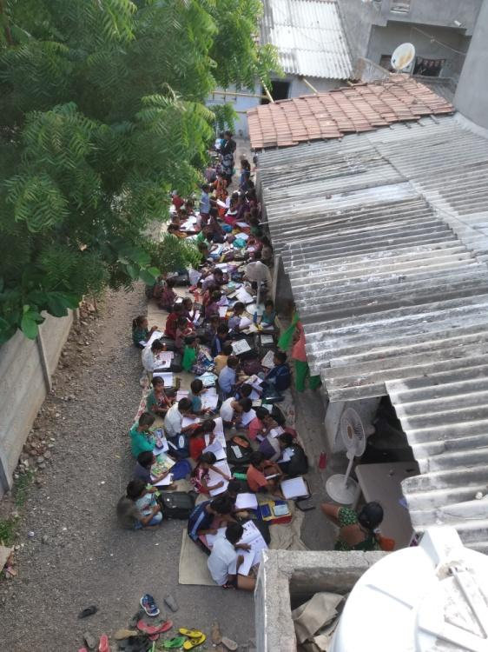
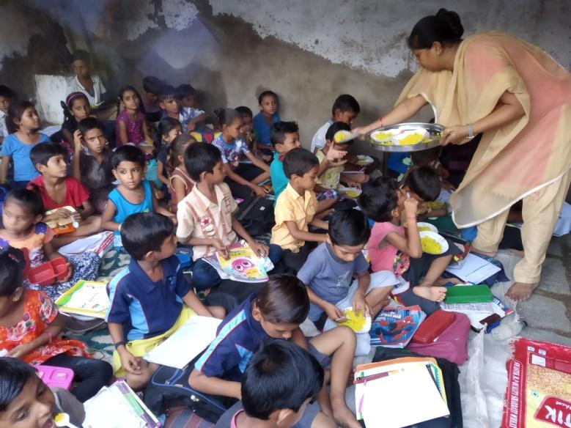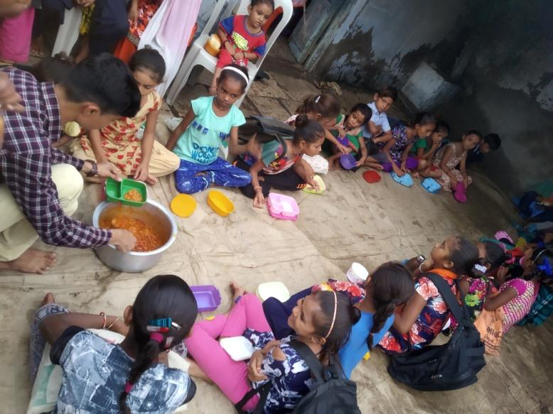
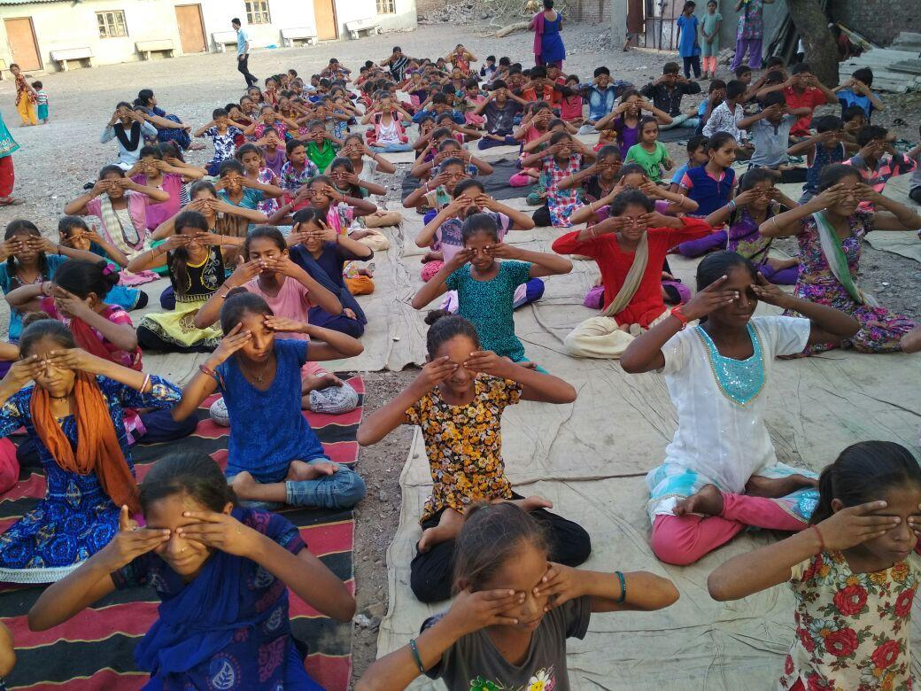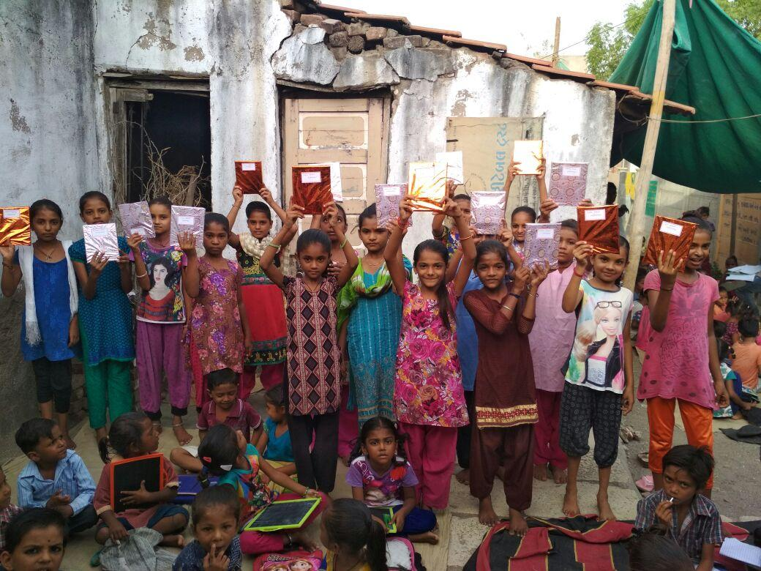

Developing Activities –
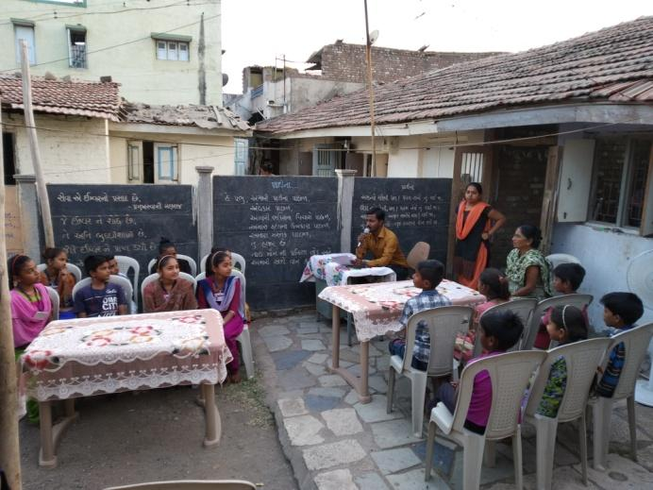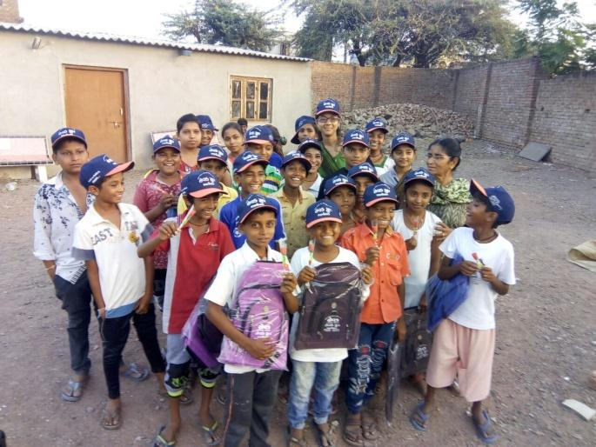
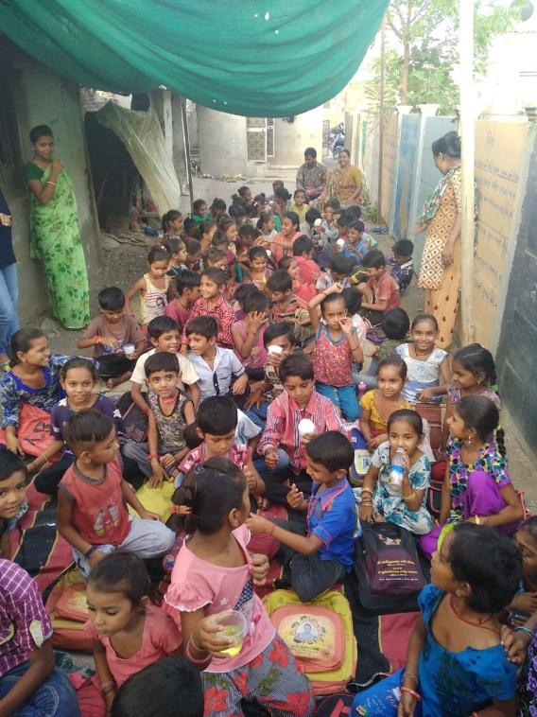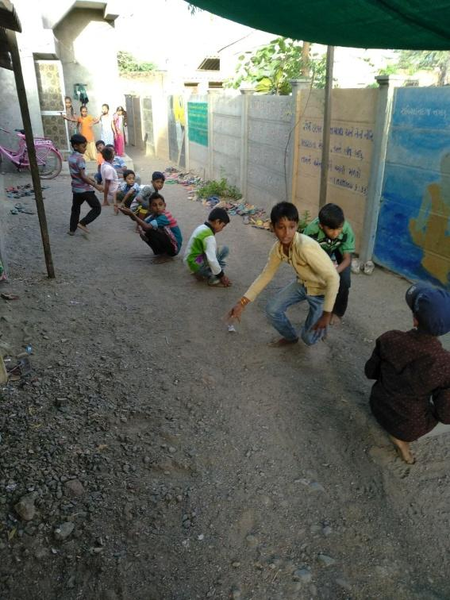
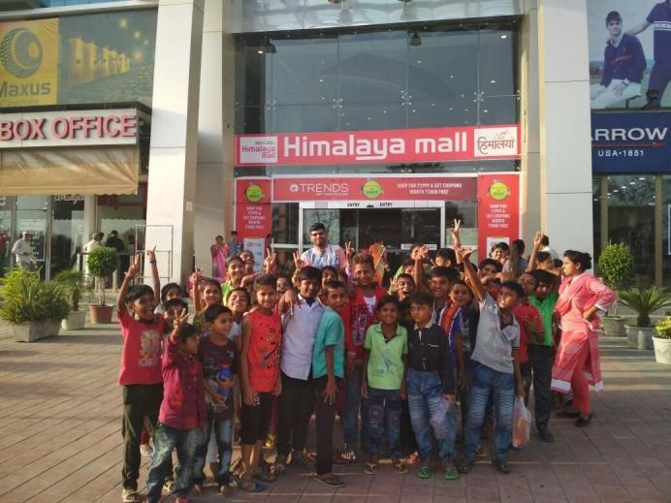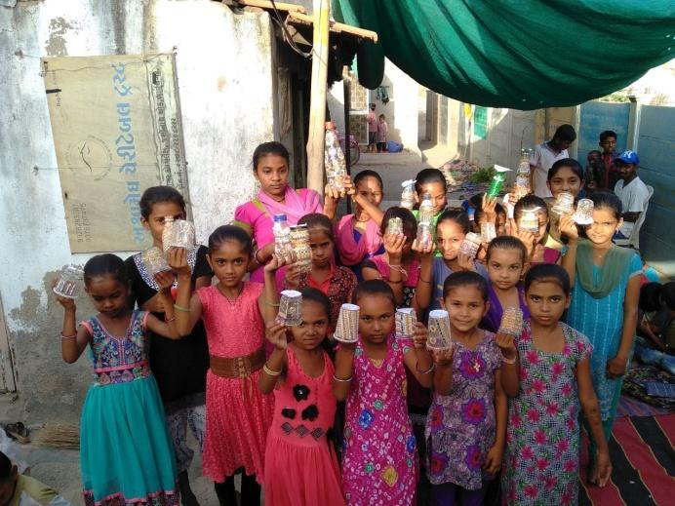

Vacation Camp –
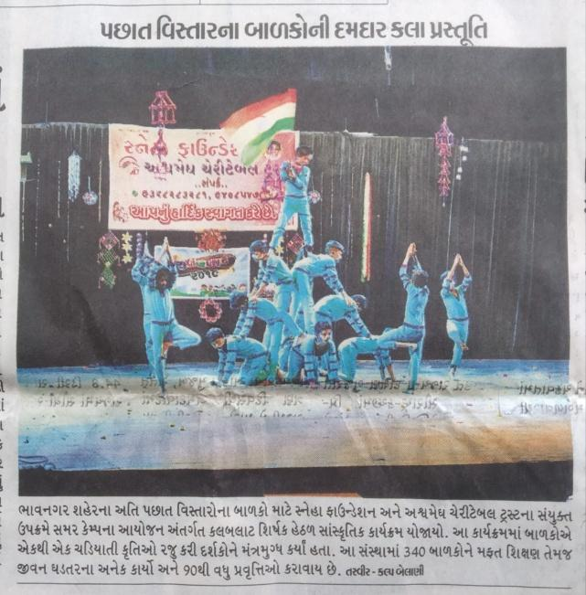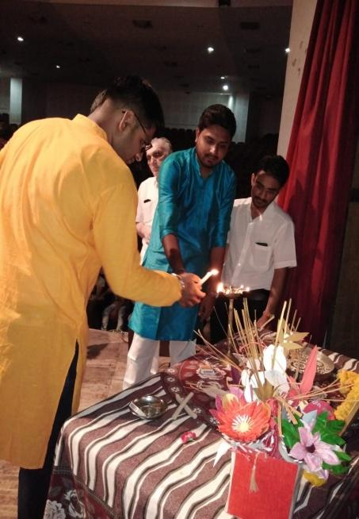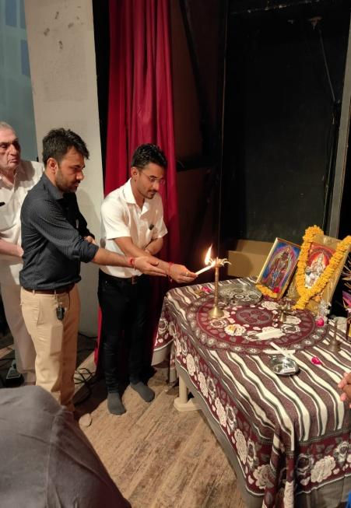
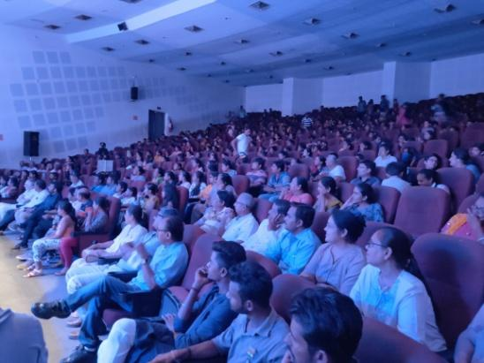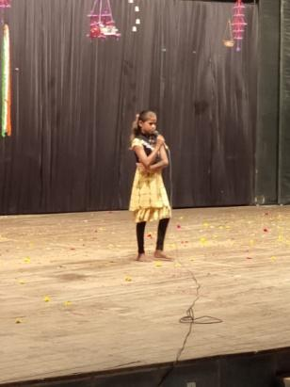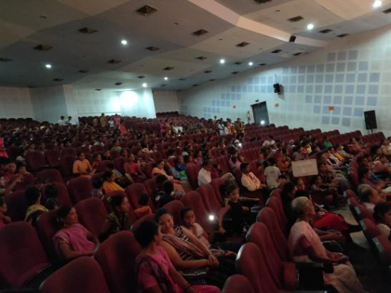
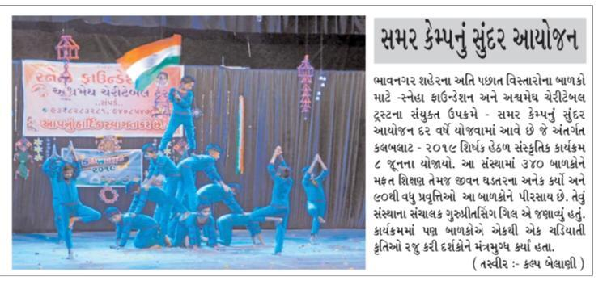

Festival Celebration –
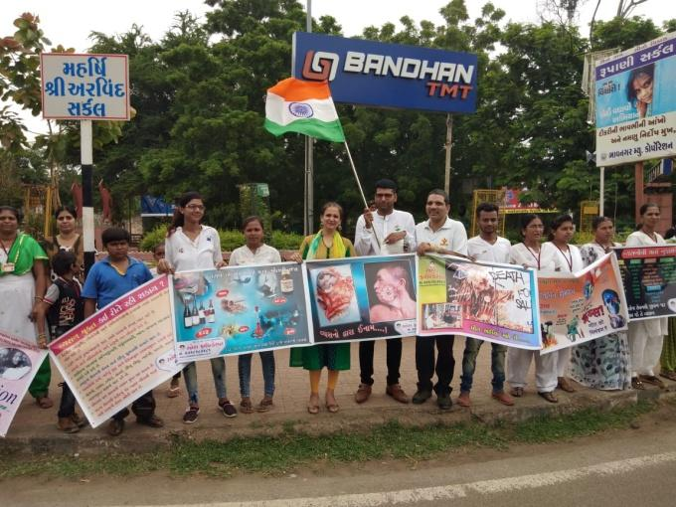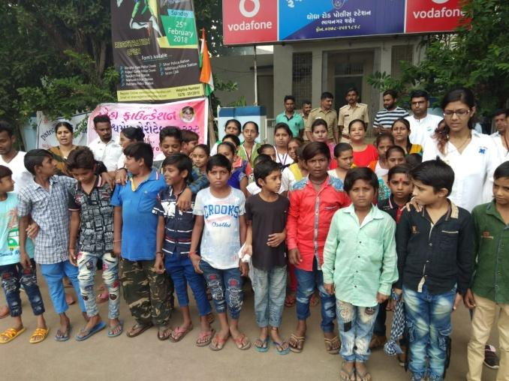
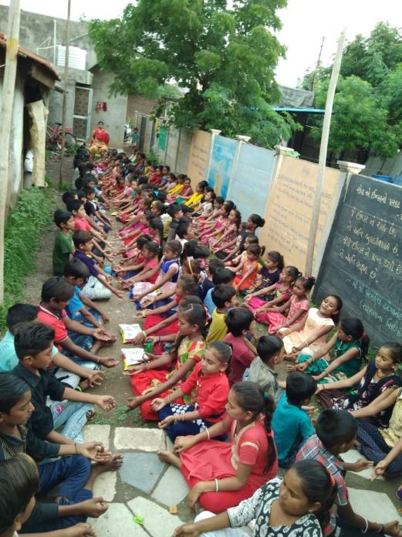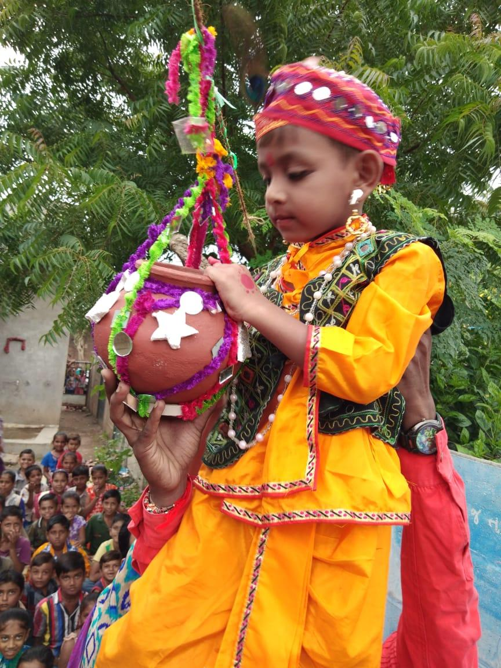
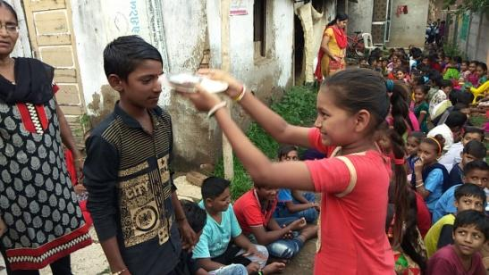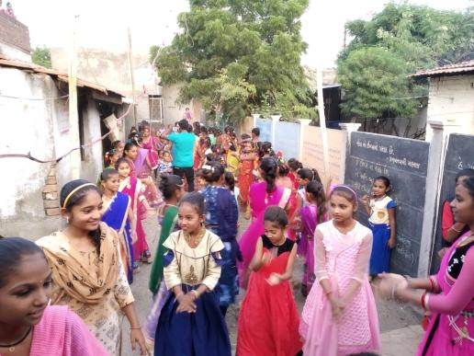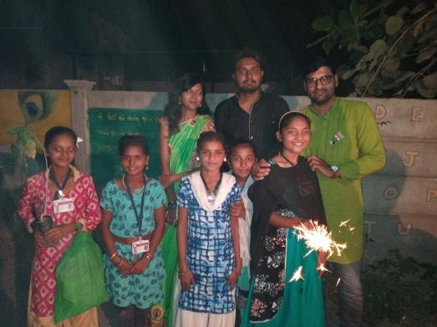

Life skills -
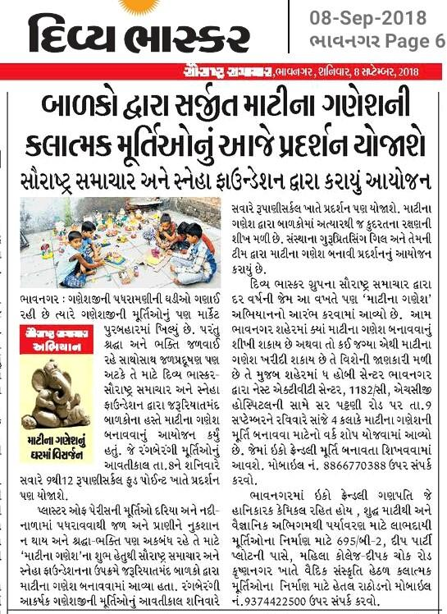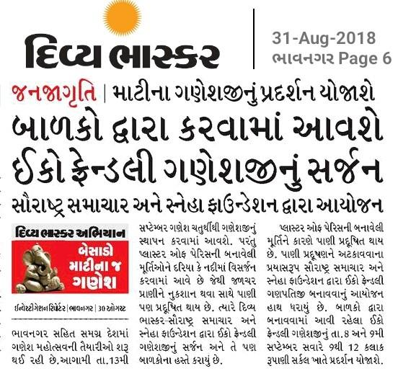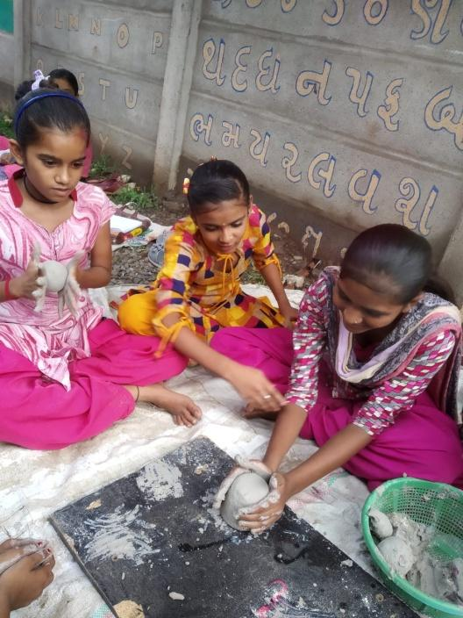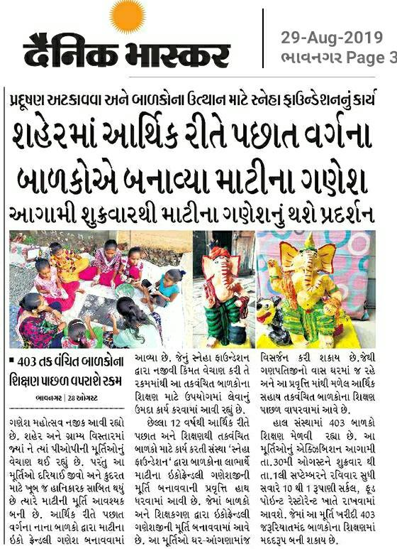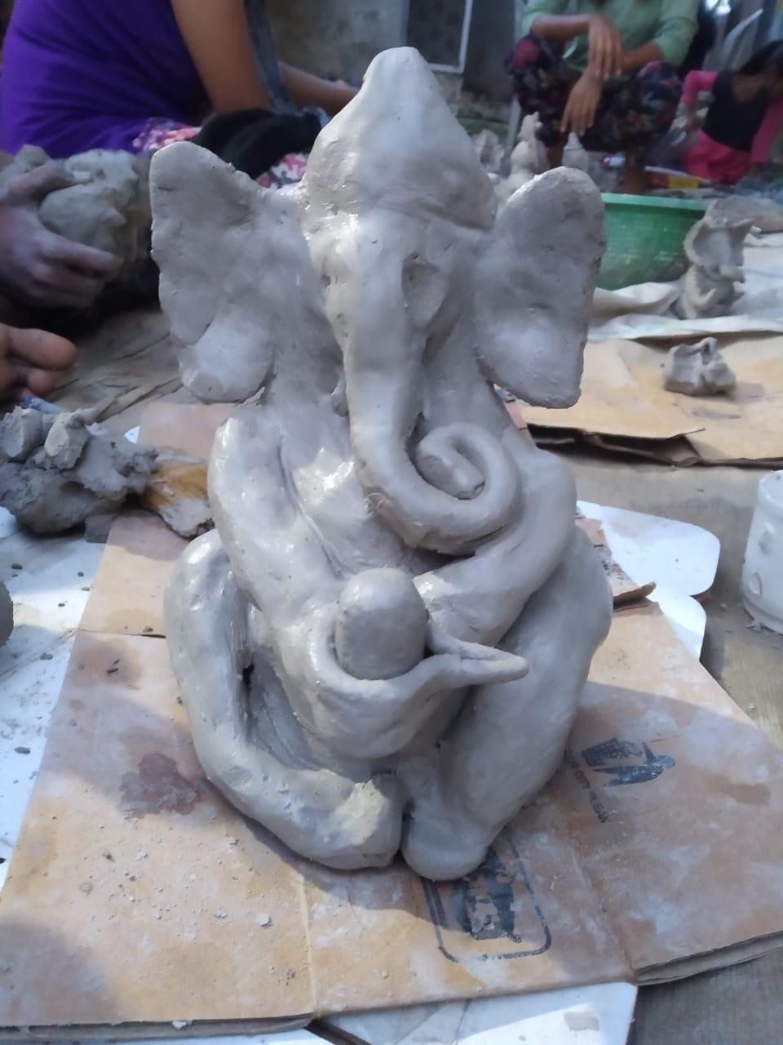
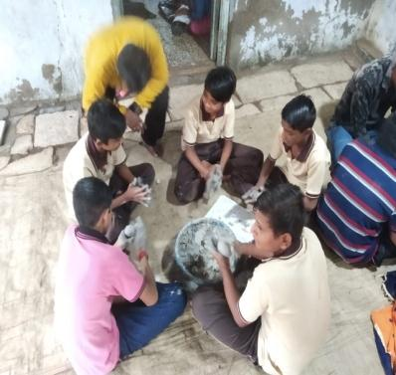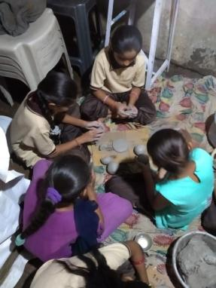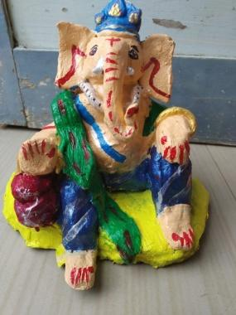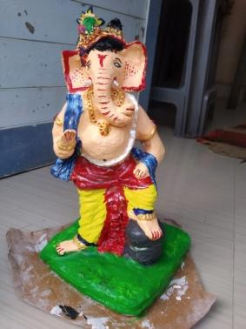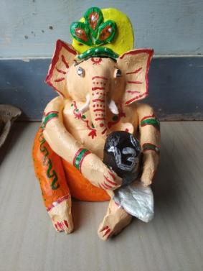

Educational Tour –
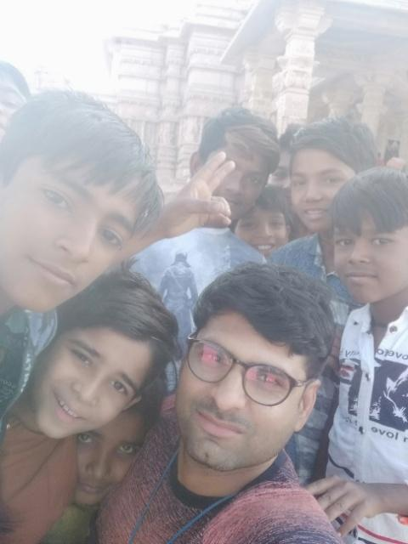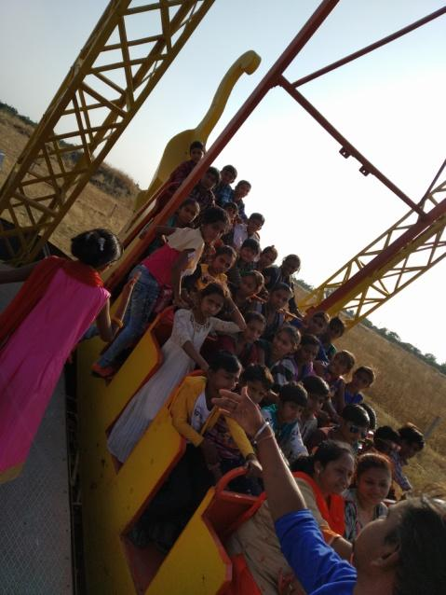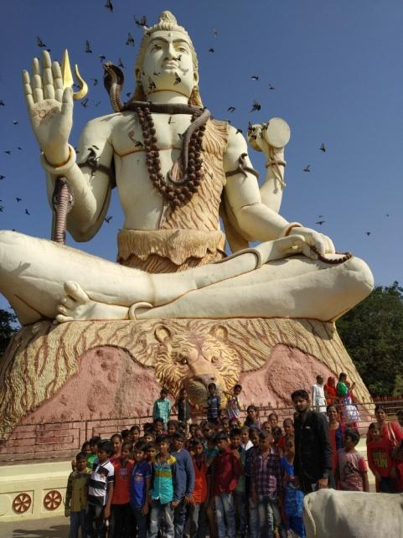
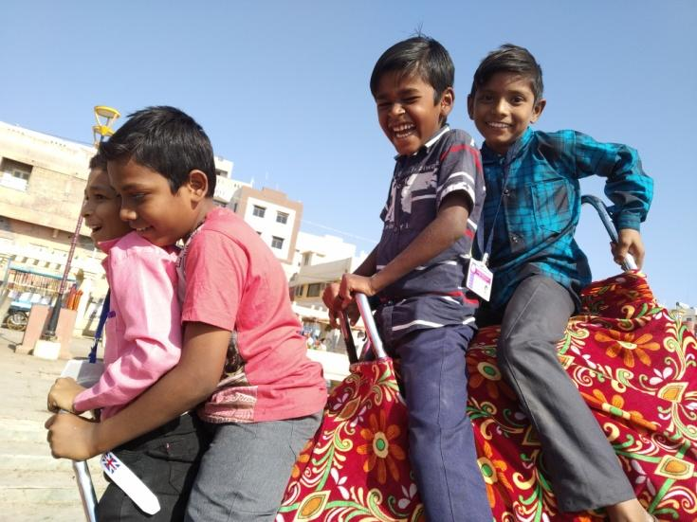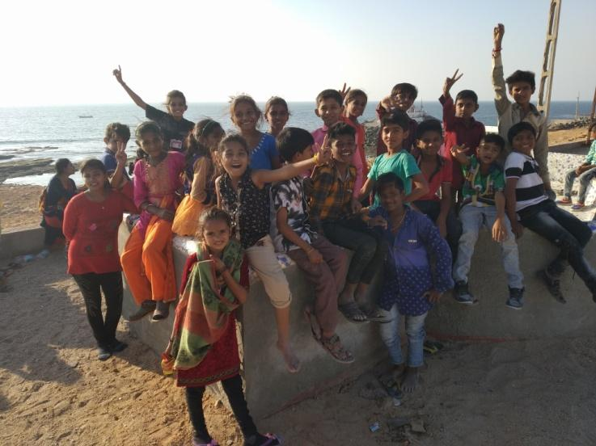

Late Shree Maltiben J Gill
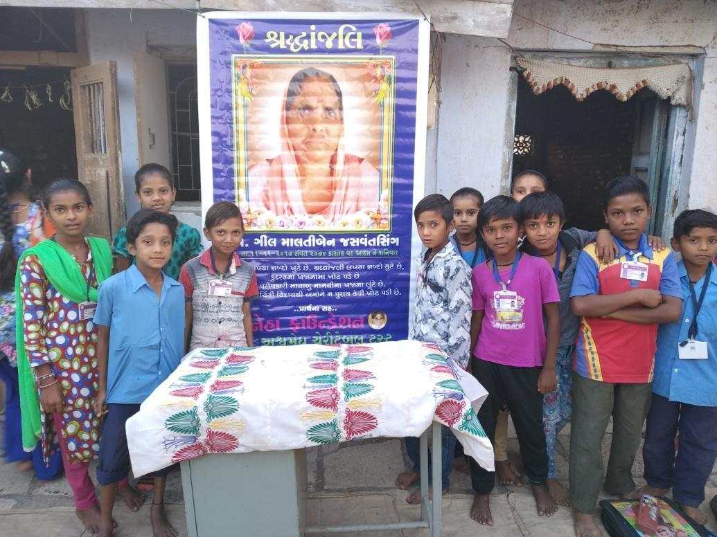
Health oriented activities...
• Mobile Dispensary -
On the occasion of the completion of 10 years of the organization in September 2016, the organization undertook health oriented activities along with education. "Sneha Foundation" has been working for the upliftment of the society by carrying out health related activities in the backward areas of Bhavnagar and the surrounding backward villages for the last 5 years.
In which we are working to improve the health of the people using Ayurvedic, Homeopathic, Allopathy and Naturopathic including the backward areas of Bhavnagar such as Khedutvas, Anandnagar, Nanu Kumbharwada, Popatnagar, Shivnagar, Dhananagar, Ramapirnagar, Mil ni chali, Shantinagar, Prabhudas talav .We are working to improve the health of people in urban areas like Kumbharwada, Devipujak Nagar etc. and in the surrounding backward villages like Kala Talao, Narmad, Khetakhatli, Sanes, Bhadbhid, Kotda, etc. in rural areas through "Mobile Dispensary".
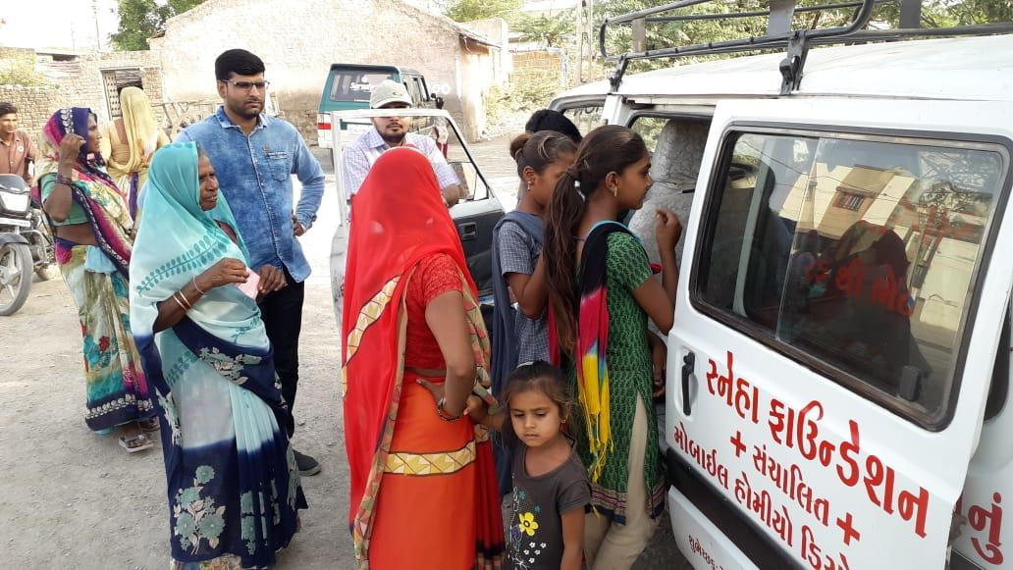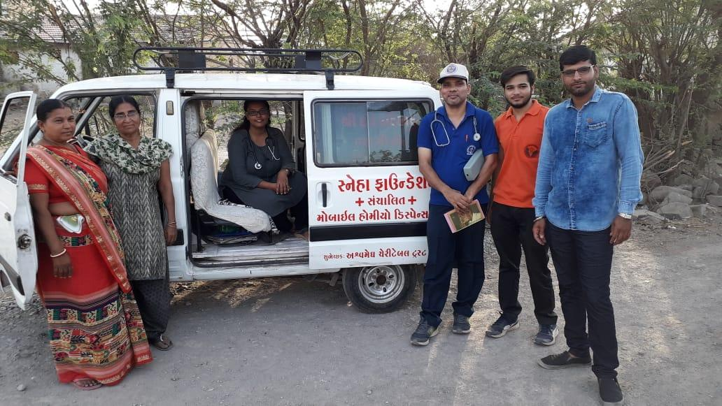
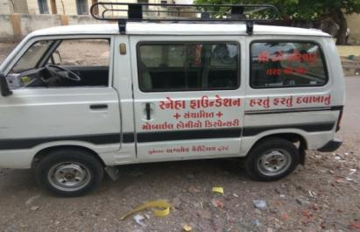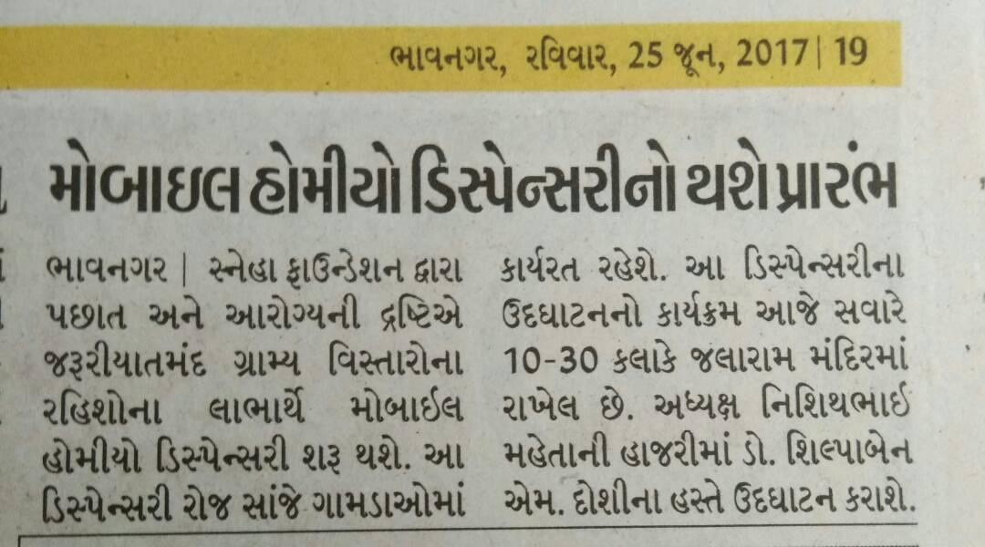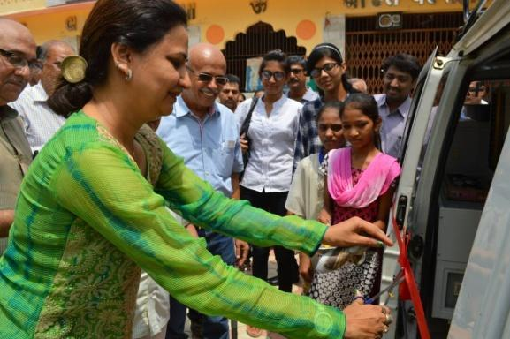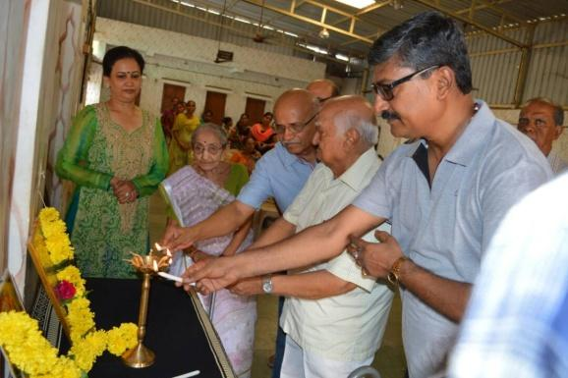

Primary Treatment Center (Public Dispensary):
Along with this a public dispensary is being run in a very backward area like Khedutvas. The primary treatment center "Public Dispensary" is being run by the organization in Khedutvas area. In this public hospital we offer all the treatments like homeopathic, allopathic and naturopathic at a very concessional rate.
Medical Camps:
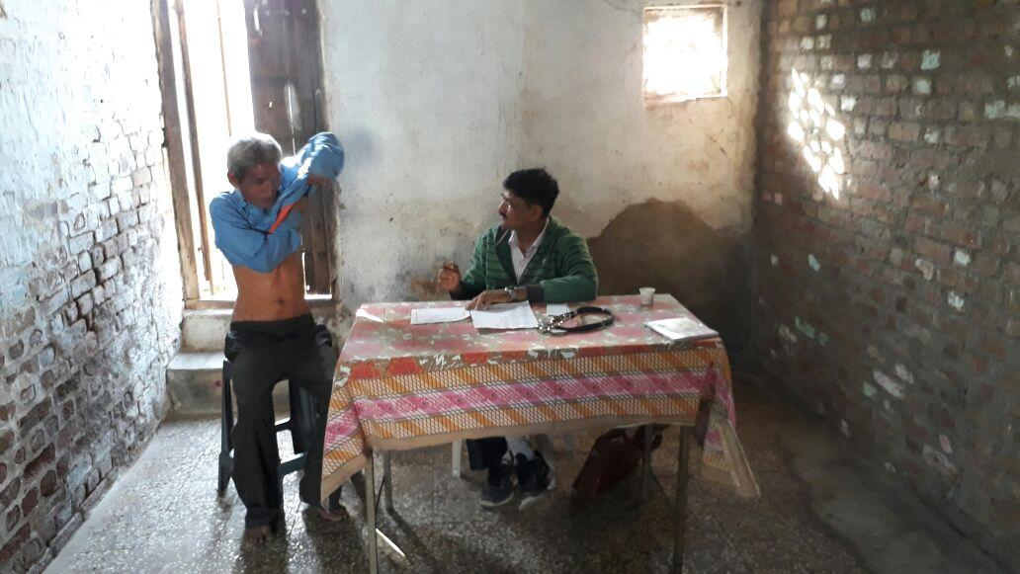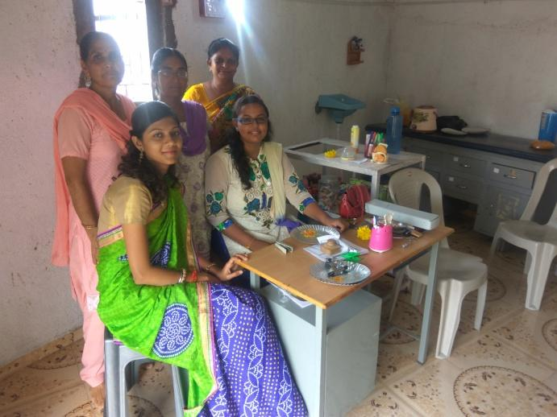
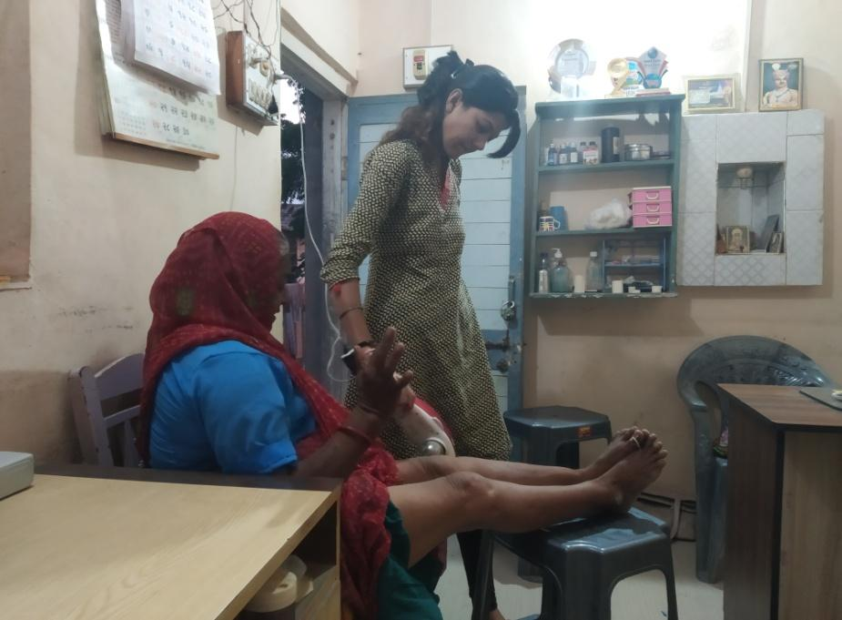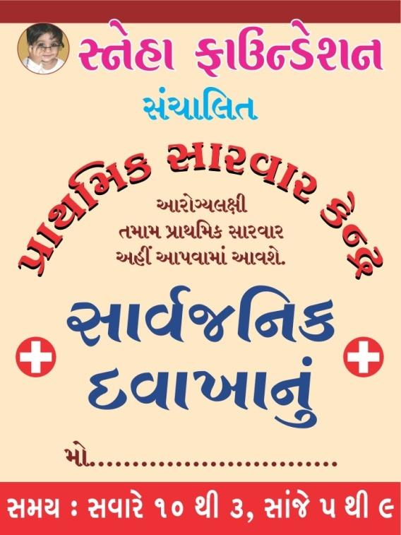
Along with this, the institute organizes homeopathic, allopathic and naturopathic medical camps in the backward areas every month in which all types of treatment are provided free of cost.

Activities with Adolescents -
In view of our years of experience and circumstances, we are making efforts to identify, understand and control the physical, mental and emotional changes that occur in adolescents, including safety and security.
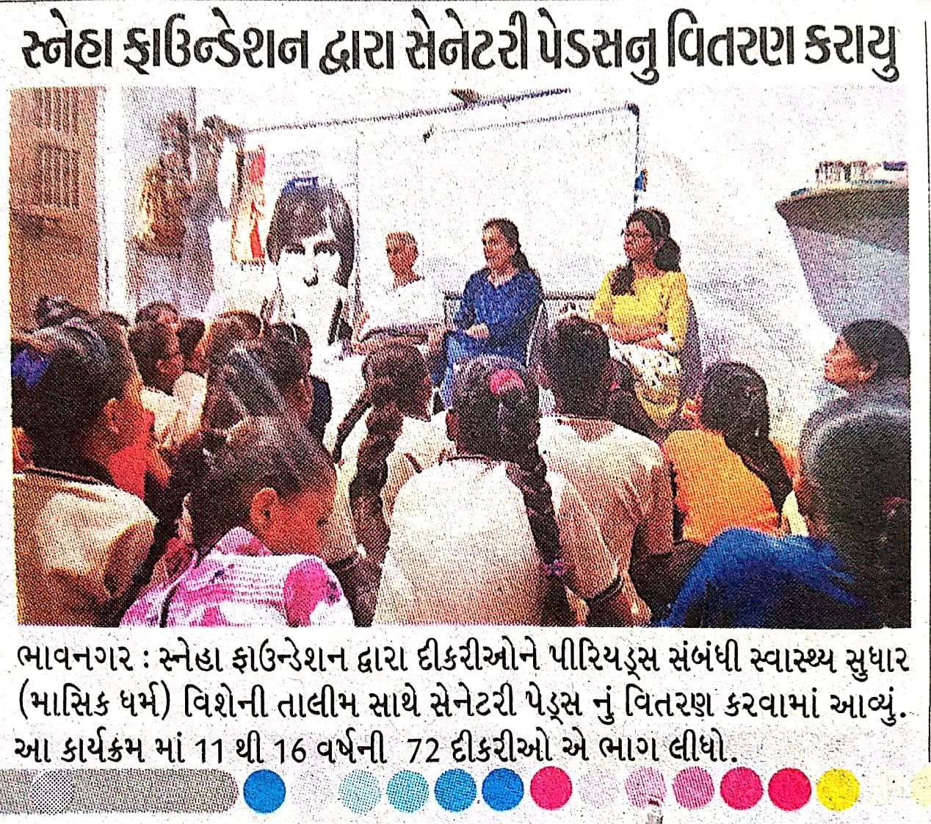
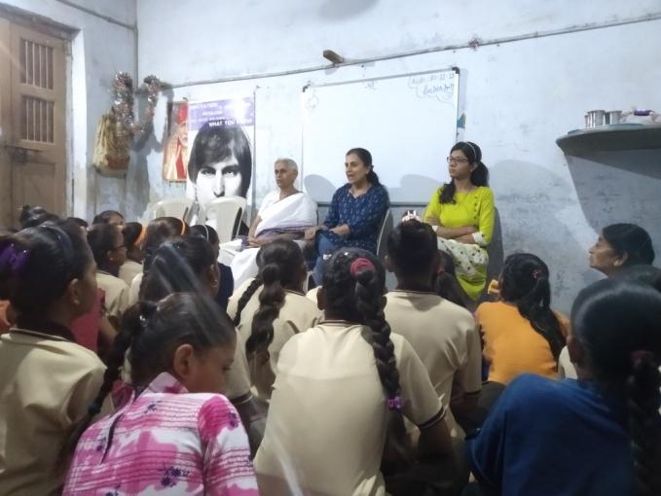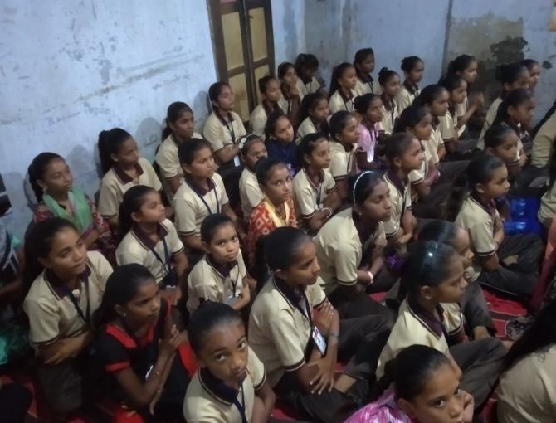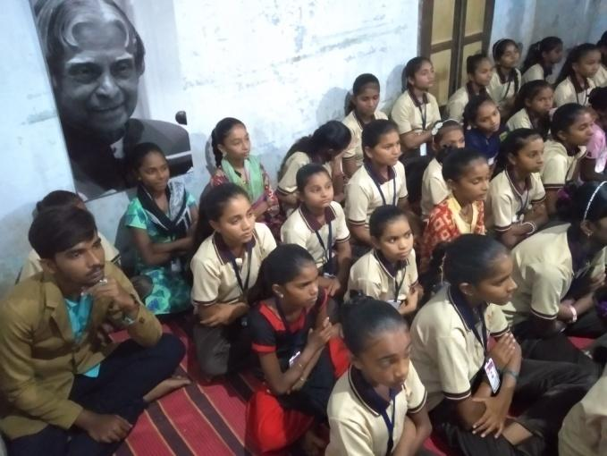

Working on so that at this stage to correct answers to the questions arising in the minds of the sons and daughters are found and turned in the right direction, it does not happen that the children go astray through the increasing social media or other perishable means to know the answers to these questions.
This is an attempt to give a true understanding in the mind of children in which we are doing other types of trainings on this subject such as health oriented, swachhata oriented and self defense etc. Along with this, have a quiet discussion with the children, talk and bring a kind of awareness in the children.

In economically backward areas, children from 11 to 17 years of age are given trainings in very simple language on different subjects by different speakers with the help of Sneha Foundation. Sanitary pads are distributed by the Sneha Foundation along with the discussion on different topics related to hygiene or Periods related health improvement (menstruation) training program.
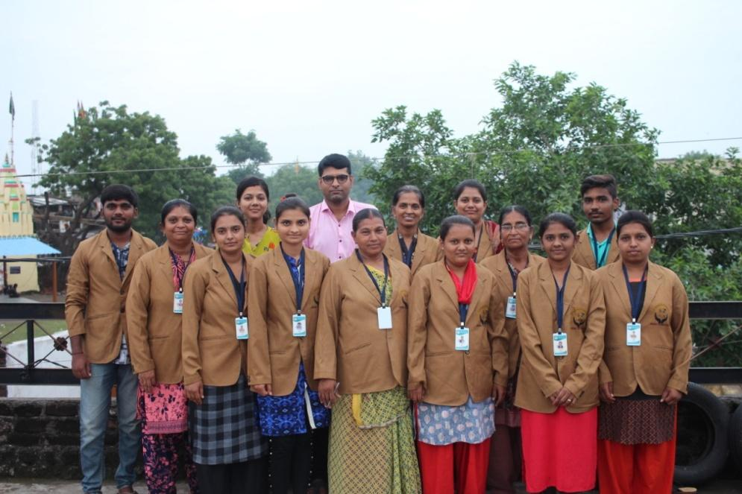
Sneha Foundation, Bhavnagar, Gujarat – 364005.
Contact us – +91 9328283281 / +91 9586863218.
Thank You…

